Experiment 4

AIM:-
Implement A* search algorithm by identifying and analyzing the given problem to reach the goal state.

THEORY:-
The informed search algorithm is more useful for large search spaces. Informed search algorithms use the idea of heuristic, so it is also called Heuristic search. Heuristic is a function which is used in Informed Search, and it finds the most promising path. It takes the current state of the agent as its input and produces the estimation of how close agent is from the goal.
A* search is the most commonly known form of best-first search. It uses the heuristic function h(n), and costs to reach the node n from the start state g(n). It has combined features of UCS and greedy best-first search, by which it solves the problem efficiently. A* search algorithm finds the shortest path through the search space using the heuristic function.

f(n) = g(n) + h(n)
Where f(n) represents the final cost
g(n) = cost of traversing from one node to another
h(n) = heuristic approximation of the node's value

Algorithm:
Step1: Place the starting node in the OPEN list.
Step 2: Check if the OPEN list is empty or not, if the list is empty then return failure and stop.
Step 3: Select the node from the OPEN list which has the smallest value of evaluation function (g+h), if node n is goal node then return success and stop, otherwise
Step 4: Expand node n and generate all of its successors, and put n into the closed list. For each successor n', check whether n' is already in the OPEN or CLOSED list, if not then compute the evaluation function for n' and place it into Open list.
Step 5: Else if node n' is already in OPEN and CLOSED, then it should be attached to the back pointer which reflects the lowest g(n') value.
Step 6: Return to Step 2.
Advantages:
- A* search algorithm is the best algorithm than other search algorithms.
- A* search algorithm is optimal and complete.
- This algorithm can solve very complex problems.
Disadvantages:
- It does not always produce the shortest path as it is mostly based on heuristics and approximation.
- A* search algorithm has some complexity issues.
- The main drawback of A* is memory requirement as it keeps all generated nodes in the memory, so it is not practical for various large-scale problems.
Example:
In this example, we will traverse the given graph using the A* algorithm. The heuristic value of all states is given in the below table so we will calculate the f(n) of each state using the formula f(n)= g(n) + h(n), where g(n) is the cost to reach any node from start state.
Here we will use an OPEN and CLOSED list.
Complete: A* algorithm is complete as long as:
- Branching factor is finite.
- Cost at every action is fixed.
Optimal: A* search algorithm is optimal if it follows below two conditions:
- Admissible: the first condition requires for optimality is that h(n) should be an admissible heuristic for A* tree search. An admissible heuristic is optimistic in nature.
- Consistency: Second required condition is consistency for only A* graph-search.
If the heuristic function is admissible, then A* tree search will always find the least cost path.
Time Complexity: The time complexity of A* search algorithm depends on heuristic function, and the number of nodes expanded is exponential to the depth of solution d. So the time complexity is O(b^d), where b is the branching factor.
Space Complexity: The space complexity of A* search algorithm is O(b^d)
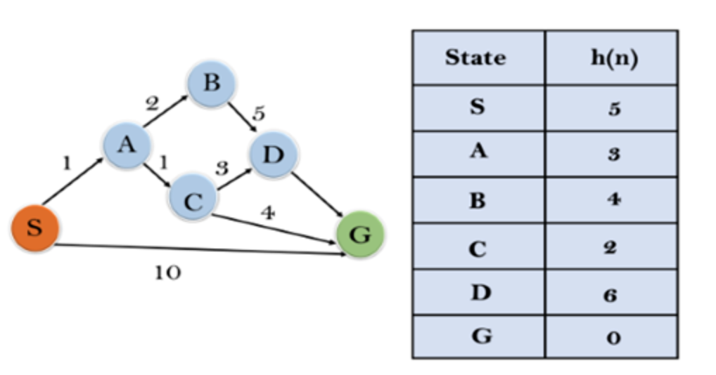
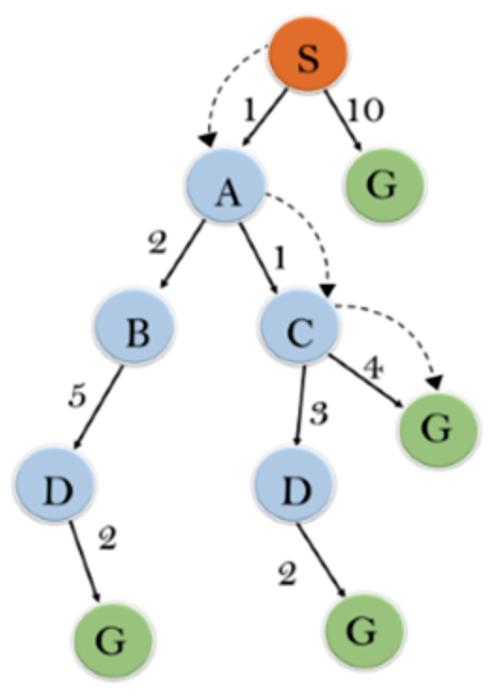
Solution-
Initialization: {(S, 5)}
Iteration 1: {(S--> A, 4), (S-->G, 10)}
Iteration 2: {(S--> A-->C, 4), (S--> A-->B, 7),
(S-->G, 10)}
Iteration3: {(S--> A-->C--->G, 6), (S--> A-->C--->D, 11),
(S--> A-->B, 7), (S-->G, 10)}
Iteration 4 will give the final result, as S--->A--->C--->G
it provides the optimal path with cost 6.

Code:-
import math
import heapq

class Cell:
def __init__(self):
self.parent_i = 0
self.parent_j = 0
self.f = float('inf')
self.g = float('inf')
self.h = 0

def is_valid(row, col):
return 0 <= row < ROW and 0 <= col < COL

def is_unblocked(grid, row, col):
return grid[row][col] == 1

def is_destination(row, col, dest):
return row == dest[0] and col == dest[1]

def calculate_h_value(row, col, dest):
return math.sqrt((row - dest[0]) ** 2 + (col - dest[1]) ** 2)

def trace_path(cell_details, dest):
print("The Path is ")
path = []
row = dest[0]
col = dest[1]

while not (cell_details[row][col].parent_i == row and cell_details[row][col].parent_j == col):
path.append((row, col))
temp_row = cell_details[row][col].parent_i
temp_col = cell_details[row][col].parent_j
row = temp_row
col = temp_col

path.append((row, col))
path.reverse()

for i in path:
print("->", i, end=" ")
print()

def a_star_search(grid, src, dest):
if not is_valid(src[0], src[1]) or not is_valid(dest[0], dest[1]):
print("Source or destination is invalid")
return

if not is_unblocked(grid, src[0], src[1]) or not is_unblocked(grid, dest[0], dest[1]):
print("Source or the destination is blocked")
return

if is_destination(src[0], src[1], dest):
print("We are already at the destination")
return

closed_list = [[False for _ in range(COL)] for _ in range(ROW)]
cell_details = [[Cell() for _ in range(COL)] for _ in range(ROW)]

i = src[0]
j = src[1]
cell_details[i][j].f = 0
cell_details[i][j].g = 0
cell_details[i][j].h = 0
cell_details[i][j].parent_i = i
cell_details[i][j].parent_j = j

open_list = []
heapq.heappush(open_list, (0.0, i, j))

found_dest = False

while open_list:
p = heapq.heappop(open_list)
i = p[1]
j = p[2]
closed_list[i][j] = True

directions = [(0, 1), (0, -1), (1, 0), (-1, 0), (1, 1), (1, -1), (-1, 1), (-1, -1)]
for dir in directions:
new_i = i + dir[0]
new_j = j + dir[1]

if is_valid(new_i, new_j) and is_unblocked(grid, new_i, new_j) and not closed_list[new_i][new_j]:
if is_destination(new_i, new_j, dest):
cell_details[new_i][new_j].parent_i = i
cell_details[new_i][new_j].parent_j = j
print("The destination cell is found")
trace_path(cell_details, dest)
found_dest = True
return
else:
g_new = cell_details[i][j].g + 1.0
h_new = calculate_h_value(new_i, new_j, dest)
f_new = g_new + h_new

if cell_details[new_i][new_j].f == float('inf') or cell_details[new_i][new_j].f > f_new:
heapq.heappush(open_list, (f_new, new_i, new_j))
cell_details[new_i][new_j].f = f_new
cell_details[new_i][new_j].g = g_new
cell_details[new_i][new_j].h = h_new
cell_details[new_i][new_j].parent_i = i
cell_details[new_i][new_j].parent_j = j

if not found_dest:
print("Failed to find the destination cell")

def main():
global ROW, COL

ROW = int(input("Enter the number of rows: "))
COL = int(input("Enter the number of columns: "))

grid = []
print("Enter the grid (0 for blocked, 1 for unblocked):")
for _ in range(ROW):
row = list(map(int, input().split()))
grid.append(row)

src_row = int(input("Enter the row index of the source cell: "))
src_col = int(input("Enter the column index of the source cell: "))
src = [src_row, src_col]

dest_row = int(input("Enter the row index of the destination cell: "))
dest_col = int(input("Enter the column index of the destination cell: "))
dest = [dest_row, dest_col]

a_star_search(grid, src, dest)

if __name__ == "__main__":
main()

Output:-
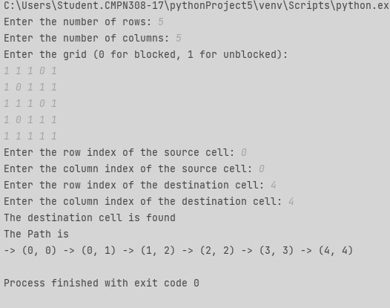

CONCLUSION:-
A* search algorithm is a heuristic-based search method used for finding the shortest path in large search spaces. It combines the features of uniform cost search and greedy best-first search to efficiently explore the search space. A* is optimal and complete under certain conditions but may not always produce the shortest path due to heuristic approximations. It has exponential time and space complexity based on the branching factor and depth of the solution. Despite its drawbacks, A* remains a widely used and effective algorithm for various problem-solving tasks.

